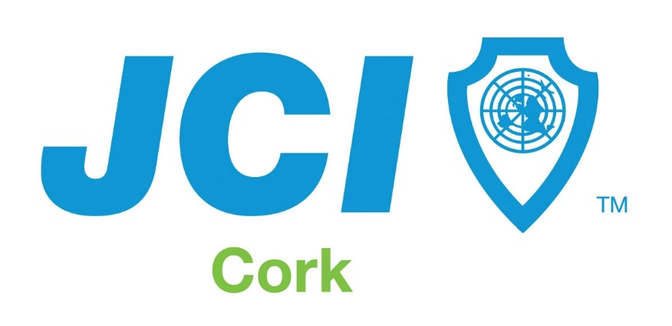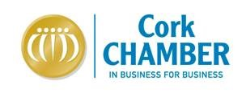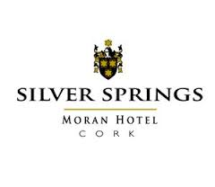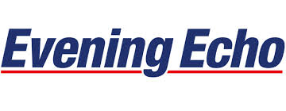
JCI Cork /Evening Echo Cork Friendly Small Business Awards 2014
In association with Silver Springs Moran Hotel and Cork Chamber
Entry Form:
Name of Business:
Address of Business:

Nominee Name:
Address of Nominee:
Tel:

Please provide details (not more than 100 words) the reasons why you think this business should be awarded the title of Cork’s Friendliest Business.

Closing Date for receipt of entries is Sunday, July 6th 2014. No correspondence will be entered into.

Entry forms should be sent to JCI / Evening Echo Friendly Business Awards, c/o Evening Echo Marketing Department, Linn Dubh, Assumption Road, Blackpool, Cork.

