
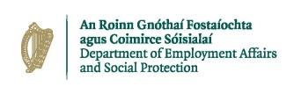

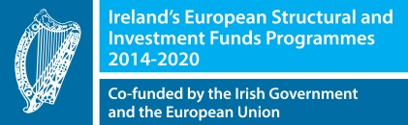


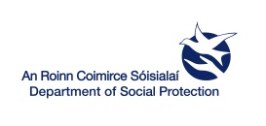

CAREERS IN IRELAND JOBS FAIR
Clayton Hotel Chiswick, London.

14th September 2019 – 10am to 5pm

INFORMATION FOR EMPLOYERS


WHAT WE CAN DO FOR YOU
• The Department of Employment Affairs & Social Protection, European Employment Services Unit, is organising a Jobs Fair
in Clayton Hotel Chiswick, London on the 14th September 2019 to assist you with your recruitment needs.

• At the Venue, we will provide you with:
- An Exhibition Stand which will include your company name, table and 2 chairs (you may bring along a popup if you wish)
- Internet Access
- Access to Catering Facilities

• We will further promote your vacancies using social media, Online, print Newspapers, etc.

ALL YOU NEED TO DO IS:
• Provide us with details of all your vacancies on the Registration Form.

• Travel to Venue and Staff your stand throughout the event and meet potential clients.

COME ALONG TO OUR RECRUITMENT EVENT AND MEET POTENTIAL CLIENTS!

If you are interested in attending, please contact your local EURES Adviser or Email us at
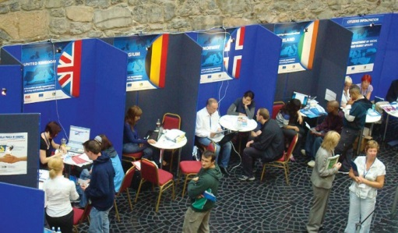
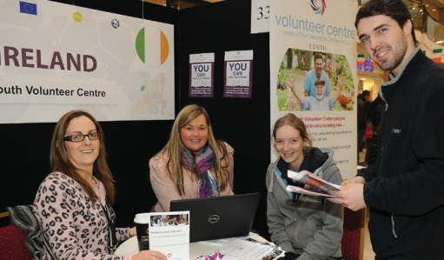
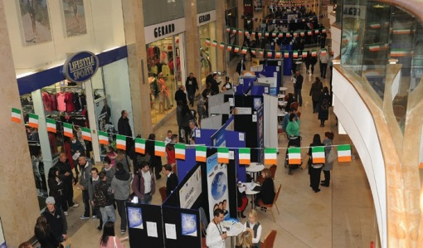
EuresEvents@welfare.ie

